HW3 for Kexin Huang

NetId: kh2383

|  |  |
| --- | --- |
| Grammar | Lexicon |
| **S -> NP VP**  **NP -> NNS**  **NP -> NP PP**  **NP -> DT NP**  **NP -> JJ NNS**  **NP -> NN NN**  **PP -> IN NP**  **NP -> DT NN**  **VP -> VBP SBAR**  **VP -> VBP PP**  **SBAR -> IN S** | * ***Scientists***= **NNS** * ***think***= **VBP** * ***that***= **IN** * ***any***= **DT** * ***habitable***= **JJ** * ***areas***= **NNS** * ***on***= **IN** * ***the***= **DT** * ***planet***= **NN** * ***are***= **VBP** * ***in***= **IN** * ***the*** = **DT** * ***border***= **NN** * ***region***= **NN** |

Penn Tree:

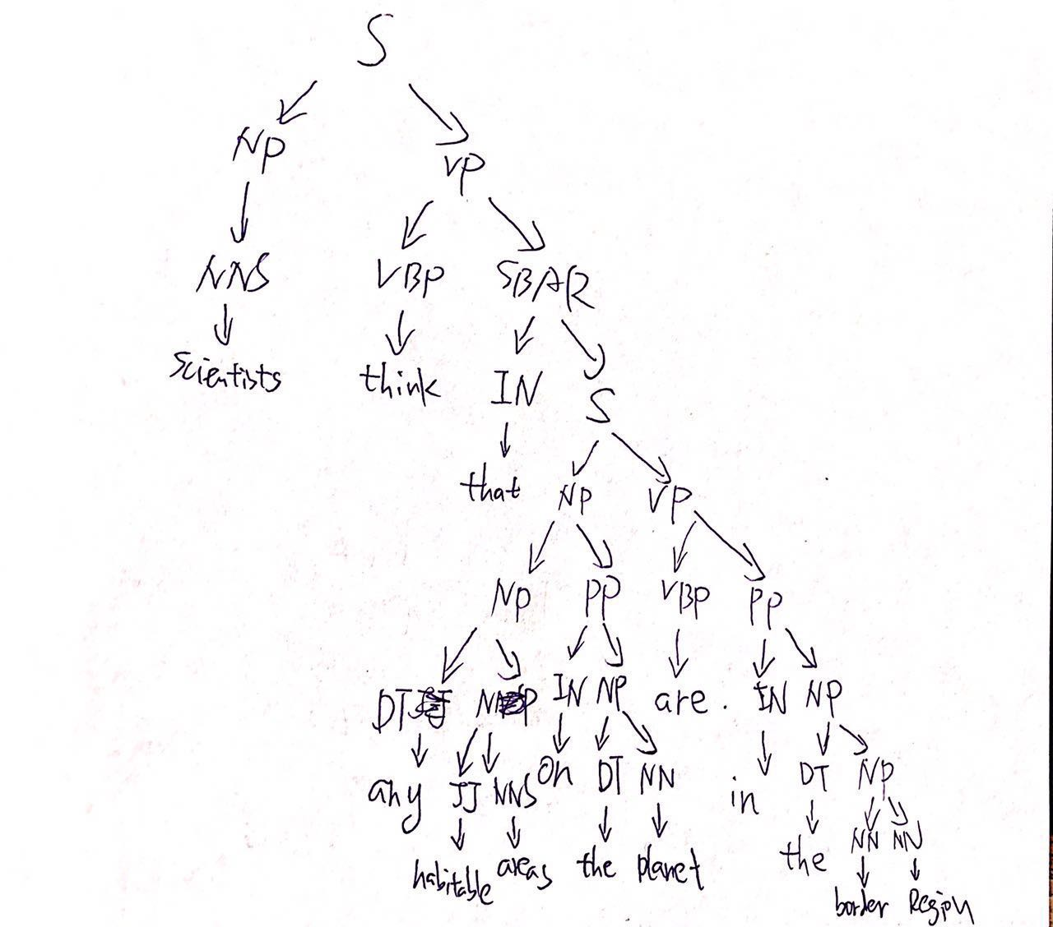

difficulty: there may be some redundancy in the grammar structure.

2. See the ipython code in the file written in python 2

and the result is here:

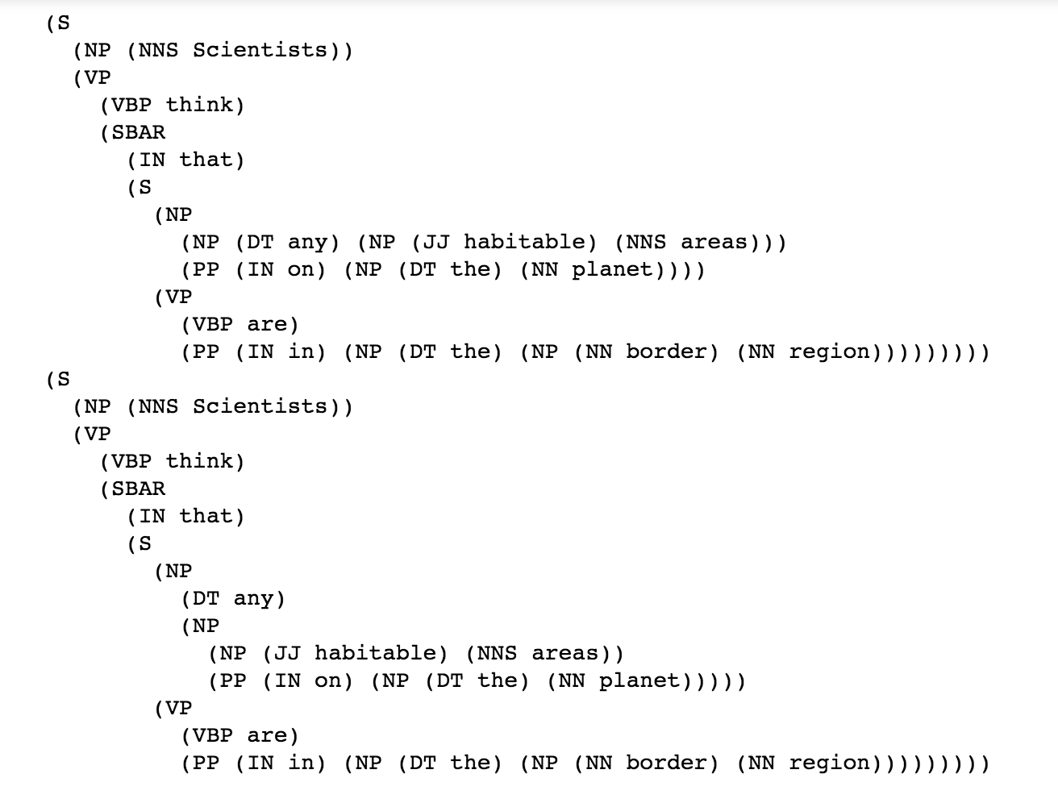

Problem 3: next page

3.

|  |  |  |  |  |  |  |  |  |
| --- | --- | --- | --- | --- | --- | --- | --- | --- |
|  | Any | Habitable | Areas | Are | In | The | Border | region |
|  | 1 | 2 | 3 | 4 | 5 | 6 | 7 | 8 |
| 0 | DT | / | NP | / | / | / | S | S |
| 1 |  | JJ | NG,NNS,NP | / | / | / | S | S |
| 2 |  |  | NNS,NP | / | / | / | S | S |
| 3 |  |  |  | VBP | / | / | VP | VP |
| 4 |  |  |  |  | IN | / | PP | PP |
| 5 |  |  |  |  |  | DT | NP | NP |
| 6 |  |  |  |  |  |  | NN,NG | NG |
| 7 |  |  |  |  |  |  |  | NN,NG |